Wrestling
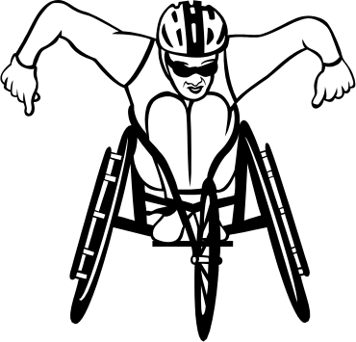
This being the first section of my portfolio, I though I would start at the beginning – at the part of my life that I’m most well known for (at least around school). Hopefully this will serve as an anchor for most of my classmates, since most of you already know of me as a wrestler. For others of you, it will still serve as a good general introduction to me as a person.
I won’t say that wrestling is exactly the most important part of my life, but it’s certainly one of the most influential activities in my life – something that will stay with me until my death. I don’t consider myself to be particularly athletic. However, I’ve been a wrestler at Brookstone for something like 11 years now, and that sort of experience tends to give you a decided advantage in most sports. I would credit any success that I have achieved in my sport to that and to the quality of my coaching. Most especially, I would like to thank Mr. Larry Morgan, my coach at Brookstone for all my years here, as well as all of my assistant coaches, most recently Mr. Bo Bickerstaff and Mr. Boo Miller.

